- Name the physical quantity on which the inertia of a body depends upon.
- Find the acceleration produced by a force of 12N exerted on an object of mass 3 kg .
- An object A of mass 8 kg and an object B of mass 20 kg are to be pushed simultaneously. Which of the two has greater inertia ? Give reason for your answer.
- A forced is applied on a metal block lying on floor in one direction. Still the block does not move. Name the force which is balancing it.
- Velocity – time graph of a moving particle of mass 1 Kg is shown in figure
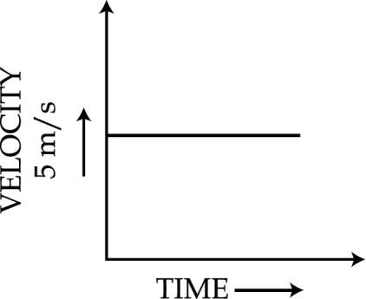

- Which has highest inertia : solids made of aluminum, steel and wood of same shape and same volume.
- Name the unbalanced force which slows down a moving bicycle when we stop pedalling it.
- State the meaning of balanced forces.
- Why is it difficult for a fireman to hold a hose, which ejects large amount of water at a high velocity.
- Give one point of difference between balanced and unbalanced forces.
- Find the momentum of a man of mass 75 kg when he walks with a velocity of 2 ms1.
- State the meaning of recoil velocity of a gun ?
- Mass of a body is doubled. How does its acceleration change under a given force ?
- Mention any two kinds of changes that can be brought about in a body by force.
- A ball is thrown vertically upwards. What is its momentum at the highest point?
- When a carpet is beaten with a stick it releases dust. Explain why ?
- Rakesh tries to push a box on a rough floor but is unable to move it. Name the force which balances the force applied by him.
- Given below are some measuring units of different physical quantities kg – ms-2, ms-2, kg-ms-1, ms-1, kg-m2 s-2. Select the units which measure force and momentum respectively.
- Why do the athletes in a high jump event made to fall either on a cushioned bed or on a sand bed ?
- Name the physical quantity which is measured by rate of change of momentum.
- During the game of table tennis, if the ball hits a player it does not hurt him. On the other hand when a fast moving cricket ball hits a spectator it may hurt him. State reason.
- In a tug of war, the rope does not move in any direction. Why?
- Name the two physical quantities that are a measure of momentum.
- Which would require a greater force – accelerating a 1 kg mass at 10 m/s2 or a 2 kg mass at 4 m/s2 ?
- Why is glass or chinaware packed with straw ?
- Mass of an object is 40 kg, what is its weight on the earth ? (Take g=10 m/s2)
- You are applying force on the pan of single pan weighing balance and the pointer points to 100g. What is the force in newtons applied by you ?
- Give the net force acting on a body at rest.
- Action and reaction are equal and opposite but even then they do not cancel each other”. Give reason.
- State action and reaction when a bullet is fired from the gun.

